Report on
Interactive Workshop on Going Global through E-commerce Marketplace for B2C Product Manufacturers, Exporters, Retailers and Online sellers
7th February 2018 between 6pm and 8pm at Hotel Poppys Vista, Tiruppur

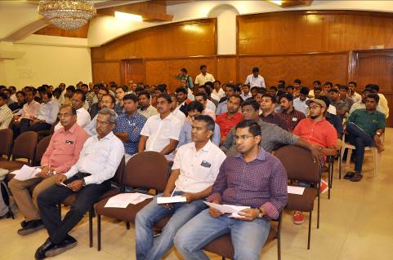
FICCI-CMSME in association with Amazon India partners organized the Interactive Workshop on Going Global through E-commerce Marketplace held on 7th February 2018 between 6pm and 8pm at Hotel Poppys Vista, Tiruppur to educate exporters on B2C exports via the e-commerce route and enable them to sell through Amazon Global Selling wherein more than 130 exporters and entrepreneurs participated.

Mr. Raghavan, Head of Business Development (Apparel Category), Global Selling, Amazon India was the Keynote speaker who made a detailed presentation on overview of B2C Marketplace in Southern India. He said categories such as apparel & accessories, leather, beauty & health products, toys and household goods have a great demand internationally. Indian exporters have a comparative advantage and immense potential here. From few hundred sellers during our launch to over 32000 sellers offering over 90 million products, Amazon Global Selling has grown and supported thousands of exporters till date and we look forward to enabling thousands more through the program.

He further said, to smoothen the selling experience for SMBs, amazon offers fulfilment services that allows exporters and manufacturers to focus on the product and pricing, offers imaging and cataloging support by getting their photo shoots done as per Amazon standards at nominal costs. He said amazon also provides access to third parties that can provide tax guidance services and other export related modalities by connecting them to concerned advisory agencies.

Mr R Sudharsan, Senior Assistant Director, FICCI TNSC, Thiru. K. M. Balajee, Assistant Director, MSME Development Institute, Govt. of India, Ministry of MSME, Chennai, Mr Sudharsan, Member of Tiruppur Exporter's Association and Mr. Prabhu Damodaran - Secretary, Indian Texpreneurs Federation also spoke on the occasion.

Photo

Caption from Left to Right (Head Table): Mr R Sudharsan, Senior Assistant Director, FICCI TNSC, Thiru. K. M. Balajee, Assistant Director, MSME Development Institute, Govt. of India, Ministry of MSME, Chennai, Mr Sudharsan, Member of Tiruppur Exporter's Association, Mr. Raghavan, Head of Business Development (Apparel Category), Global Selling, Amazon India, Mr. Prabhu Damodaran - Secretary, Indian Texpreneurs Federation.

